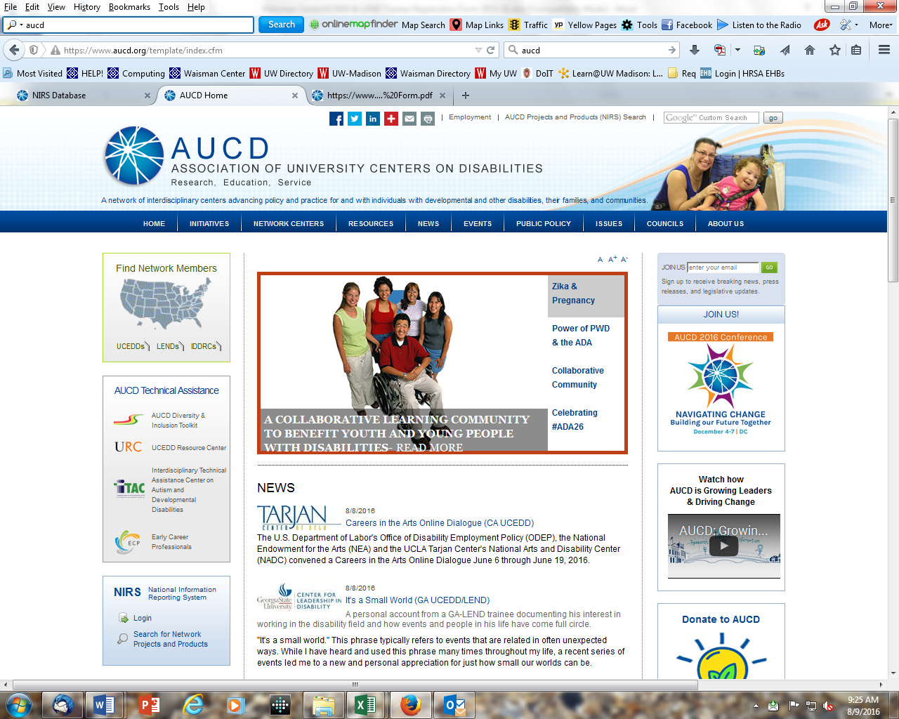

2022 LEND Trainee Registration Form – Short Term
National Information and Reporting System (NIRS)
[July 1, 2021 – June 30, 2022 = FY 2022 Reporting Period]
* Response Required

*Trainee Contact Information
First Name/ Middle Initial
Last Name
County of Origin (i.e. Dane County)
Current Phone/Cell
Personal (Primary) E-Mail Address
School (Secondary) E-Mail Address

Date of Birth: / / /

* Gender: Male / Female / / Prefer not to answer

* Race (check one):
White refers to people having origins in any of the original peoples of Europe, the Middle East, or North Africa.
Black or African American refers to people having origins in any of the Black racial groups of Africa.
American Indian and Alaskan Native refer to people having origins in any of the original peoples of North and South America (including Central America), and who maintain tribal affiliation or community attachment.
Tribe: /
Asian refers to people having origins in any of the original peoples of the Far East, Southeast Asia, or the Indian subcontinent (e.g. Asian Indian).
Native Hawaiian and Other Pacific Islander refers to people having origins in any of the original peoples of Hawaii, Guam, Samoa, or other Pacific Islands.
More than one race includes individuals who identify with two or more racial designations.
Unrecorded is included for individuals who are unable to identify with the categories.

*Ethnicity (check one): Hispanic is an ethnic category for people whose origins are in the Spanish-speaking countries of
Latin America or who identify with a Spanish-speaking culture. Individuals who are Hispanic may be of any race.
Hispanic Non-Hispanic Unrecorded

*Personal relationship with Disabilities:
Are you a … (Please check all that apply)
Person with a disability
Person with a special health care need
Parent of a person with a disability
Parent of a person with a special health care need
Family member of a person with a disability
Family member of a person with a special health care need
None of the above

*Discipline: (Check one)
Audiology | Medicine-Pediatric Pulmonology
Biological Sciences | Medicine: General
Dentistry-Pediatric | Medicine: Pediatric
Dentistry-Other | Mental and Behavioral Health
Disability Studies | Nursing
Education/Special Education | Nursing-Family/Pediatric Nurse Practitioner
Education: Administration | Nursing-Midwife
Education: Early Intervention/Early Childhood | Nursing-Other
Education: General Education | Nutrition
Epidemiology | Occupational Therapy
Family Studies | Pastoral
Family Discipline (parent, sibling) | Pharmacy
Genetics/Genetics Counseling | Physical Therapy
Gerontology | Psychiatry
Health Administration | Psychology
Human Development/Child Development | Public Administration
Interdisciplinary | Public Health
Medicine-Adolescent Medicine | Rehabilitation
Medicine-Developmental-Behavioral Pediatrics | Respiratory Therapy
Medicine-Neurodevelopmental Disabilities | Self-Advocate/Disability Advocate
Other - Please specify: ___________ | Social Work  Speech-Language Pathology

*Contact Hours in Training Program
# Weeks # hours/week Total
Summer (June – August)
Fall Semester (August – December)
Spring Semester (Jan – May)
Inter-Session (May – June)
*TOTAL Contact Hours:

(Example of Contact Hours: LEND) # Weeks # hours/week Total
Fall Semester (August – December) | 15 | 10 | = 150
Spring Semester (Jan – May) | 15 | 10 | = 150
TOTAL Contact Hours = 300 Training Contact Hours
*Upon completing training you will be: (Check one)
Long-Term Trainee? (300+ hours upon completion of training)
Intermediate Trainee? (150-299 hours upon completion of training)
Intermediate Trainee? (40-149 hours upon completion of training)
Short-term trainee? (8 - 39 hours upon completion of training)

*First Time Registered with Waisman Center? Yes No -- (list previous years) / _

*Start Date and End Date of training experience at Waisman Center: / /_ to / /
Mo Year Mo Year
*Supervisor: ________________________

